**Classification**

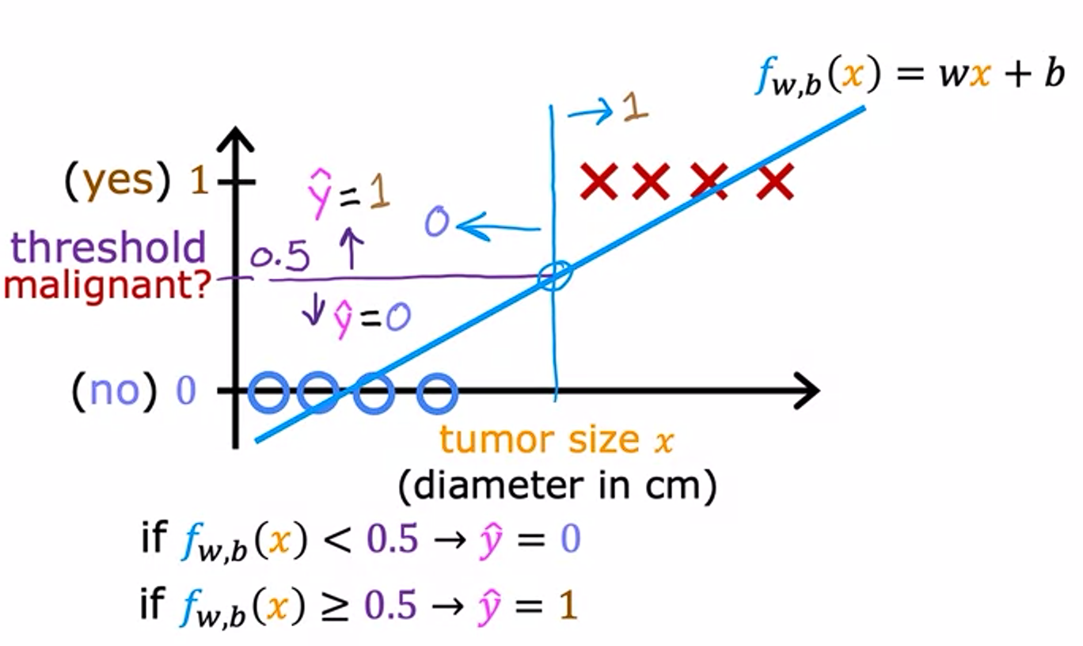

If we apply linear regression to a binary classification problem, we could define a threshold value, say 0.5. Prediction less than half are 0 and predictions greater than half are 1.

Linear Regression causes the best fit line to shift over when one large value appears. So here, the decision boundary shifts over.

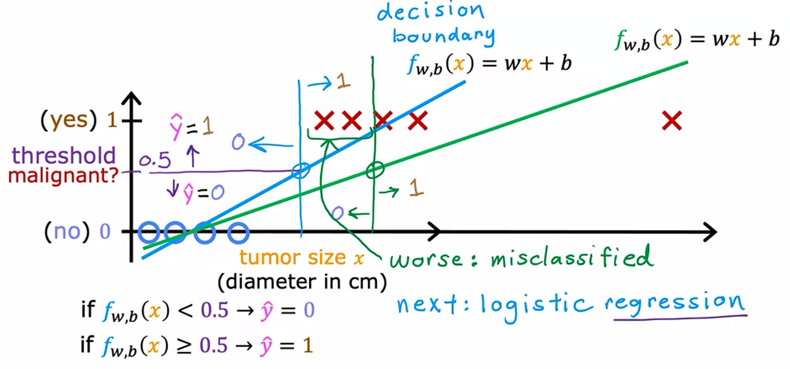

**Logistic Regression**

Even though it is named ‘regression’, it is used for binary classification problems. The name was given for historical reasons. Sigmoid/Logistic function is used.

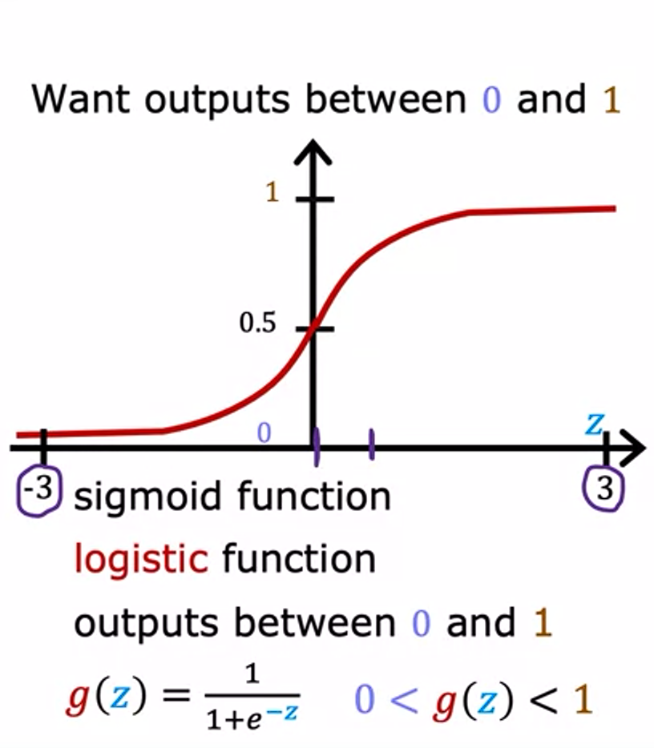

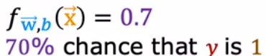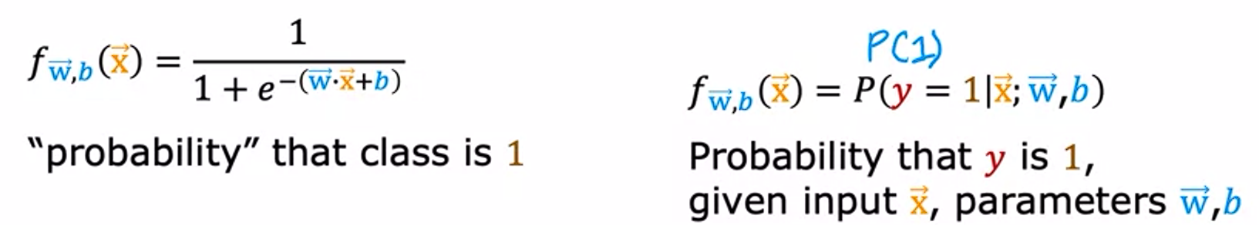

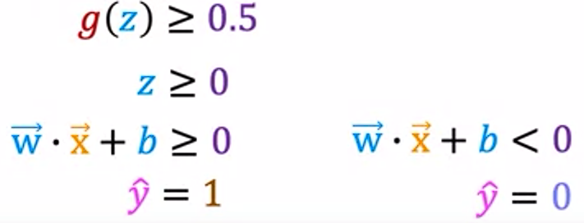

**Decision Boundary**

Put z=0, this gives us the decision boundary. Areas with z>=0 are prediction=1, while areas with z<0 are prediction=0. Depending on z, number of features used and their powers, the decision boundary could be linear or non-linear.

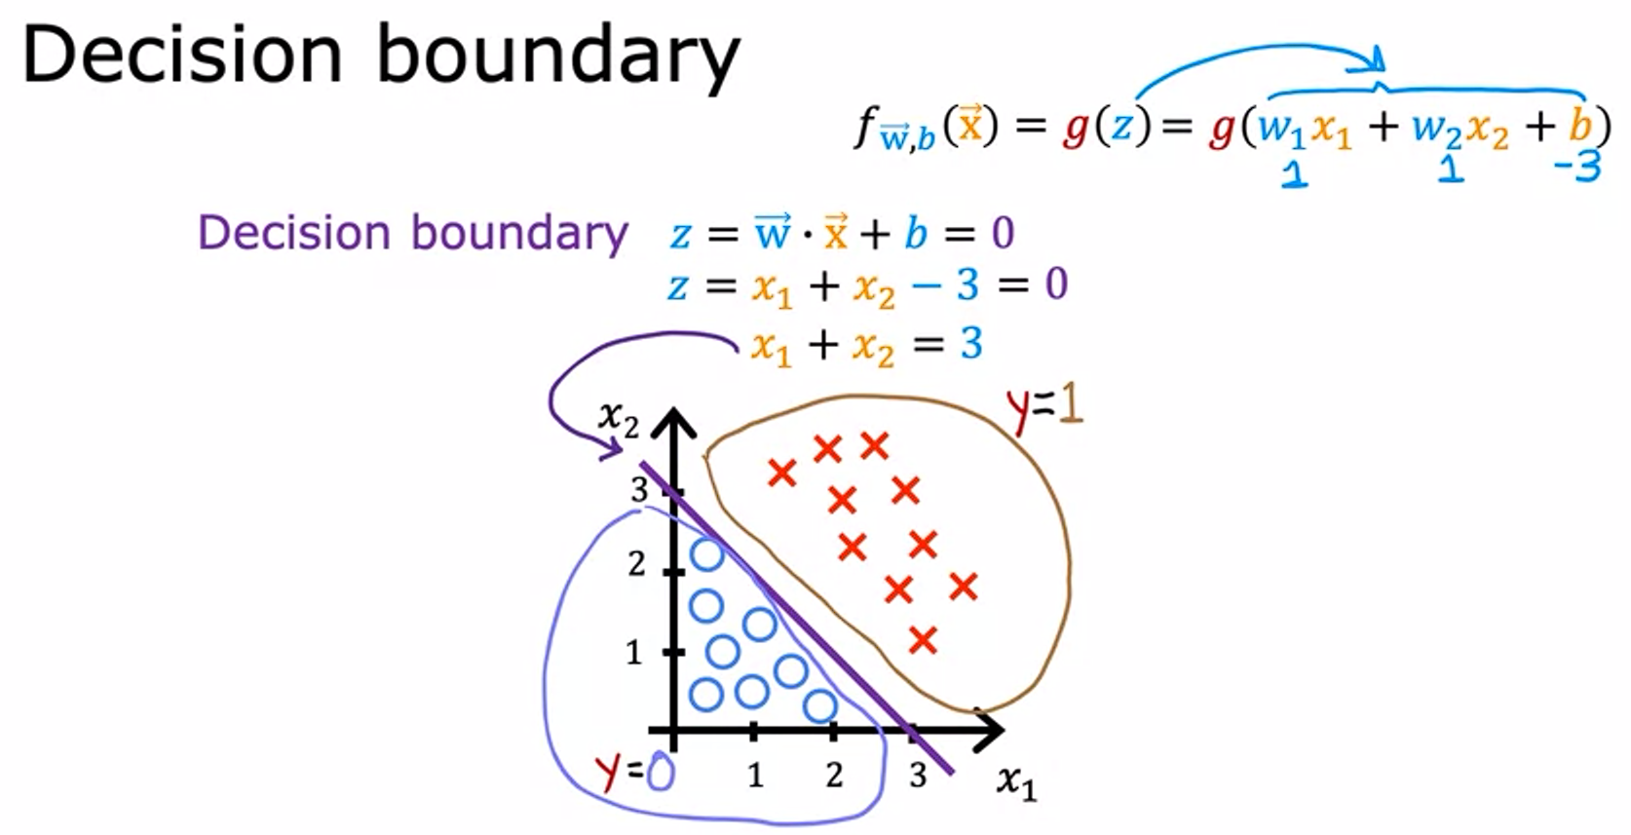

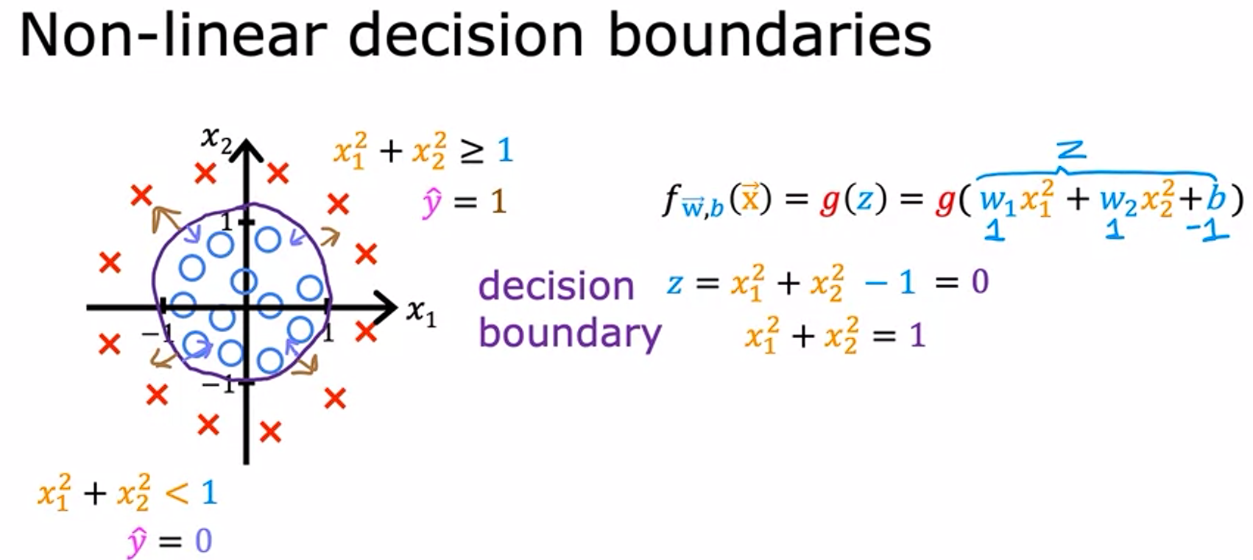

**Squared Error Cost function for Logistic Regression**

In the case of Logistic Regression, when we plot the squared error cost function, it has a non-convex shape. So, it has a lot of local minima in the plot. Hence, we cannot apply gradient descent using this error function, as we would not be able to reach global minima with this error cost function.

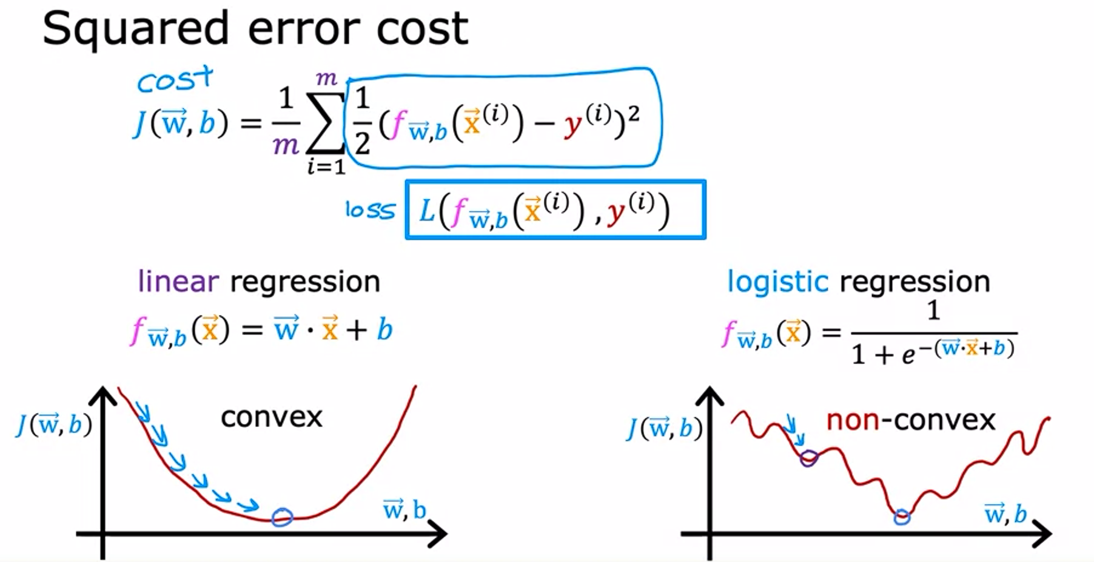

So here, we use the loss function:

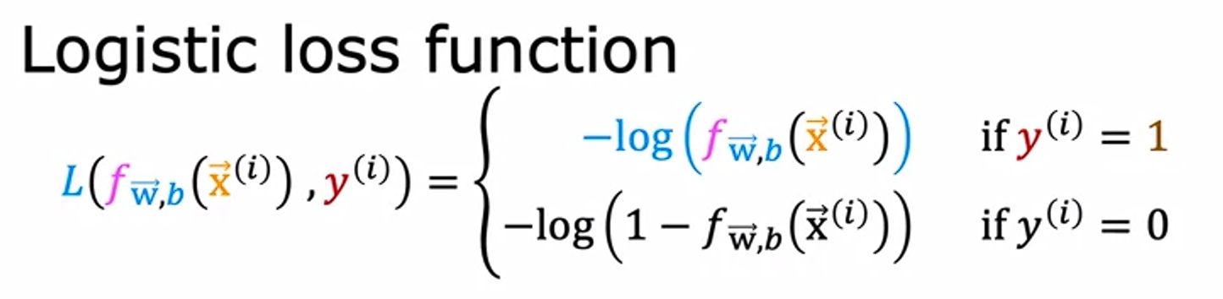

Case 1. When y=1, plotting Prediction(f_wb(xi)) vs Loss Value

Here, if prediction=0 then loss is infinite, and if prediction=1, loss=0. So the function is loss= -log(prediction)

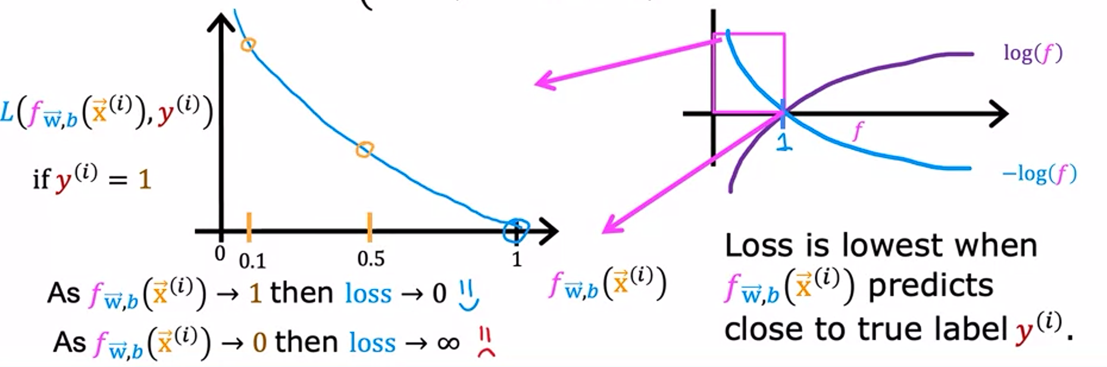

Now Case 2: When y=0, plotting Prediction(f_wb(xi)) vs Loss Value

Here, if prediction=0 then loss=0, and if prediction=1, loss is infinite. So, the function is loss= -log(1-prediction)

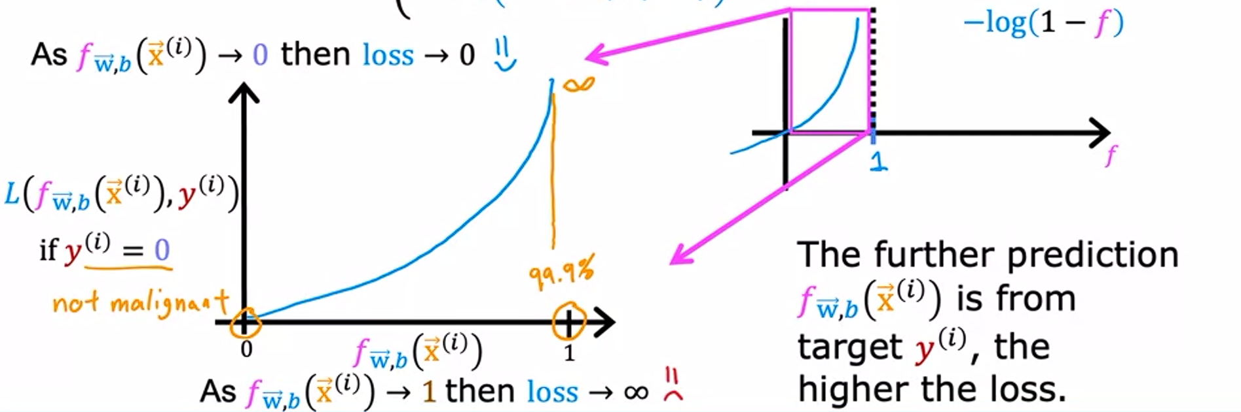

Note: There are multiple loss functions possible. This particular loss function was derived using a statistical principle called maximum likelihood estimation, which helps to efficiently find parameters for different models. Also this loss function has a useful property that it is convex.

**Simplified Loss Function:**



**Cost Value:**

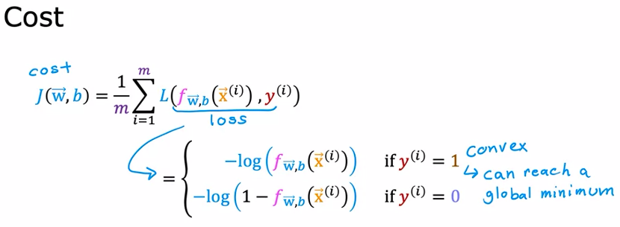Note that, for linear regression, the loss was L=½*(f_wb-y)2 per datapoint. We summed it for all m points, and took average, i.e., (1/m)*sigma(L).

So here also:

**Gradient Descent For Logistic Regression:**

The equations are similar to gradient descent for linear regression, the only change being the definition of f_wb. (The partial derivative of simplified logistics cost function turns out to be same as partial derivatives of squared error cost of linear regression, but with different f_wb)

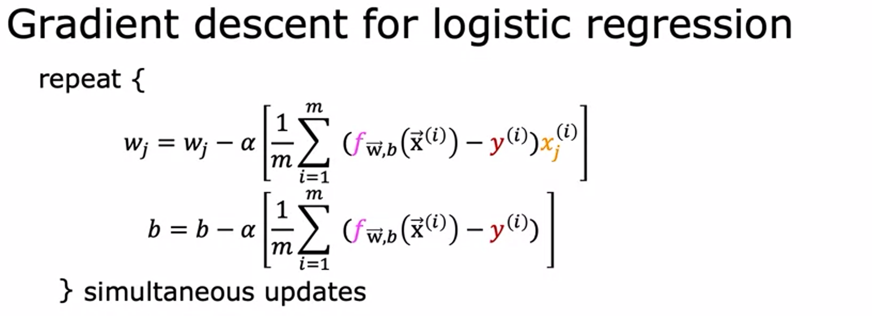

**Generalization**

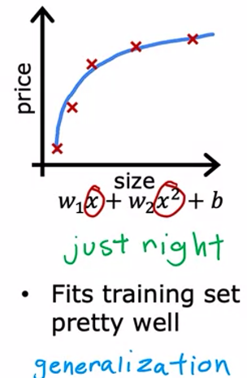Creating a learning algorithm that does well even on data that wasn’t part of the training process is called as generalization.

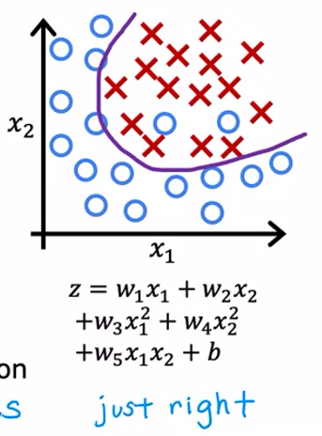

**Underfitting**

When the number of features is too low, the model doesn’t fit the training data too well. It is called Underfitting. It is said that the algorithm has high bias. (Here, bias is not referring to certain ethnicities or gender, but rather that the model has a strong perception – or bias – that the curve is going to be, say, linear, despite actual data being the contrary.)

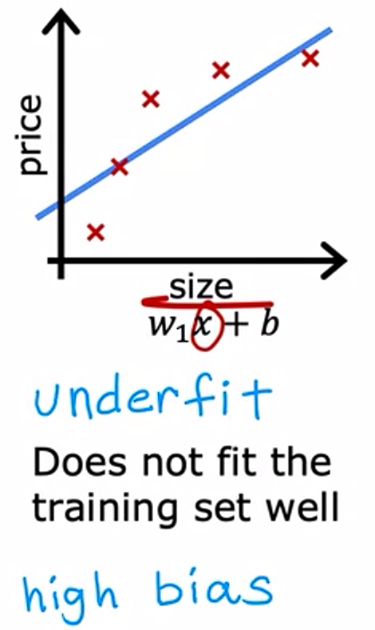 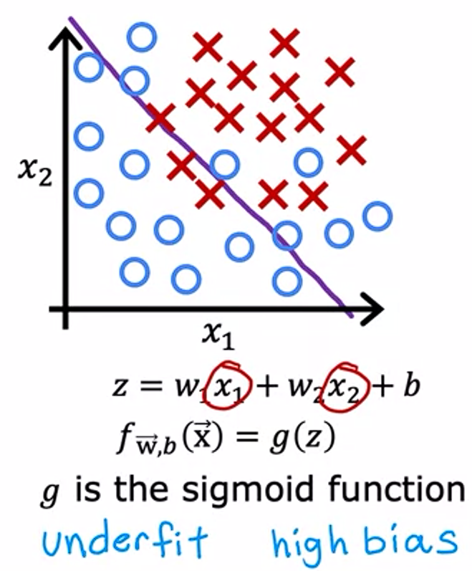

**Overfitting**

If the number of features is too high, the model can overfit the training data. Due to this, the model would not generalize too well for data not in training set. We say that the algorithm has high variance.

The algorithm is trying very hard to fit every single training example. So, if the training set was even just a little different, say, that just one datapoint was misplaced, then the function that the algorithm fits could be totally different.

So, if 2 different people took this high-feature model and tried to fit slightly different datasets, they would end up with highly variable predictions. Hence, we call it ‘high variance’.

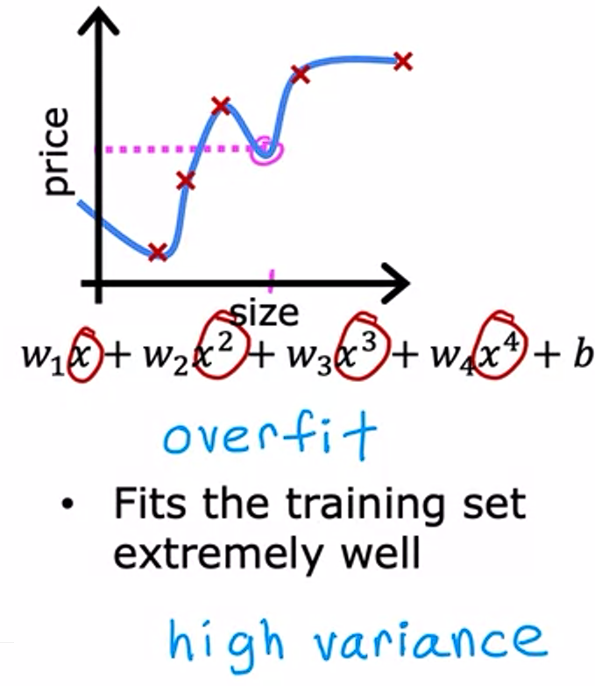 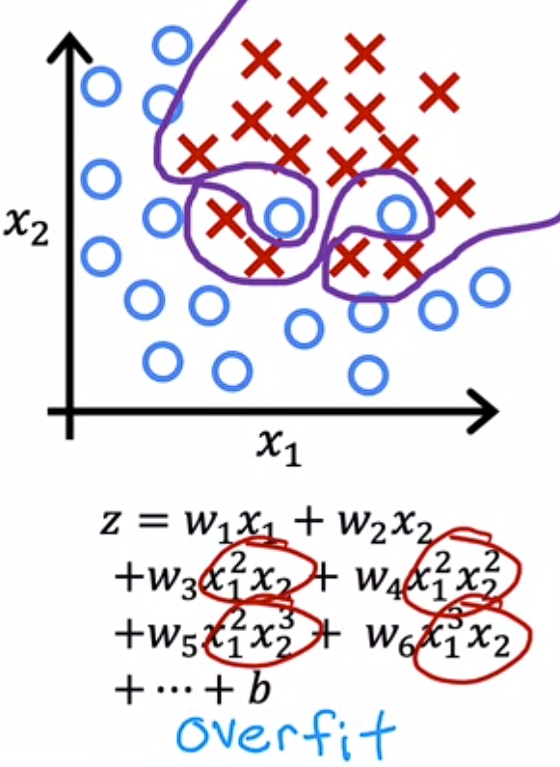

**Addressing overfitting**

* Collect more data – More Data=Better Model
* Feature selection – When we have large number of features but insufficient data, overfitting occurs. We need to select the most important (relevant) features.
* Reduce Size of parameters (Regularization) – If we wanted to eliminate effect of some features, we can just set its corresponding parameter a very small value. Regularization is a way to gently reduce impact of some features without removing them outright.

**Regularization for Linear Regression**

The main idea is that if we have smaller parameters, then we have a simpler model, which is less likely to overfit.

In the gradient descent algo, we minimize the cost function. To perform regularization, we need to minimize the parameters of useless features. So, we modify the cost function to include sum(square(parameters)) term as well, called the regularization term. So now the gradient descent algo will try to minimize not just the error/loss term but also the parameter values. So, parameters that can be reduced without significantly impacting fitting will get minimized.

Here, lambda is called the regularization parameter. We also divide the regularization term by 2m, so that both the error/loss term and regularization terms scale by 1/2m. This makes choosing lambda easier, as the same value of lambda would continue to work no matter the dataset size.

Note: We can regularize b if we want to as well, but in practice it makes very little difference.

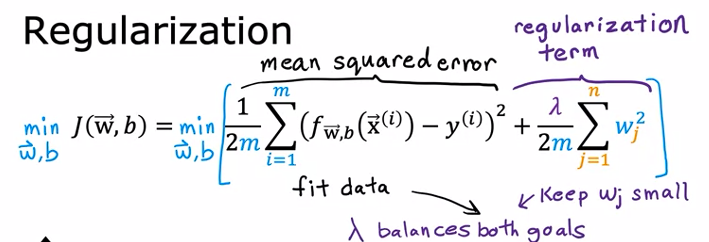

If lambda was very small, we are not using the regularization term at all, so there is chance of overfitting.

If lambda was very large, then the effect of regularization term, on the total cost, is larger than loss term. So gradient descent would prioritize reducing parameters over reducing the error/loss. This causes underfitting.

**Gradient Descent:**

Note that on taking partial derivative with a wi, all other wj become 0, and the summation is removed. We get:

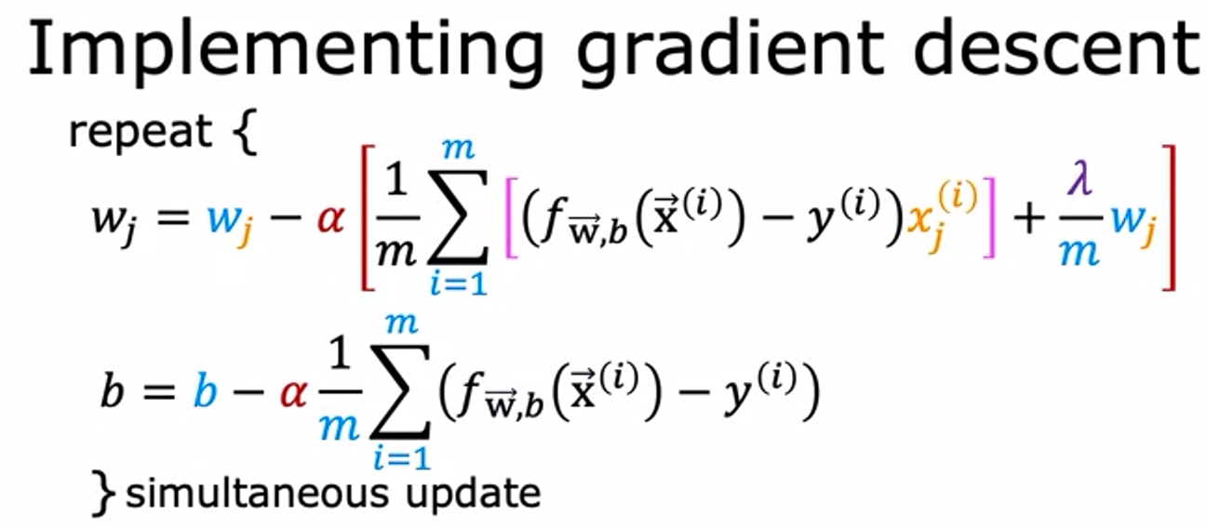

Here, the value of each w gets slightly reduced after each iteration. Alpha and Lambda are both constants set by us and m is number of points in dataset.

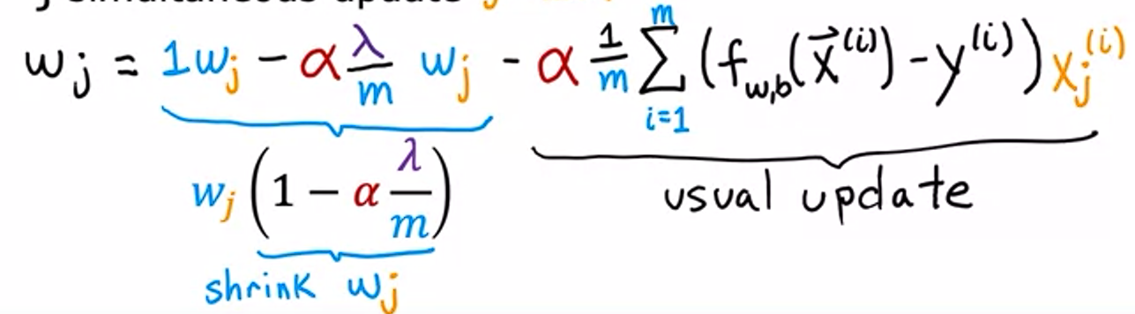

**Regularization for Logistic Regression**

